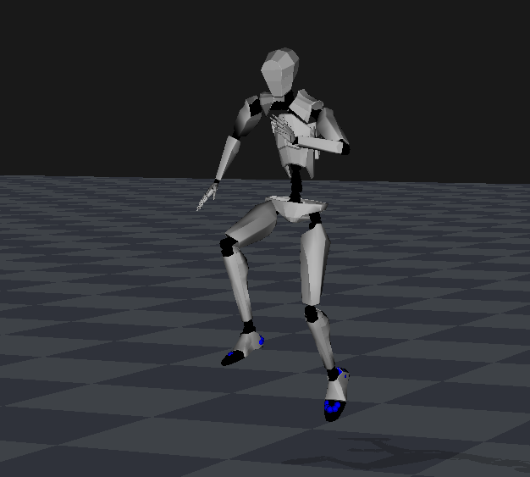

BVH TCP/IP Data Stream Format Description

By Yuanhui He, Siyuan Deng, Tobi Baumann, Haiwen Guo

PNLib SDK 3.1.26 b25
NeuronDataReader Library b11
Noitom Technology Co., Ltd.
www.neuronmocap.com

目录：
BVH TCP/IP Data Stream Format Description 1
1. Introduction 3
2. Format description 3
2.1. BVH data with displacement 3
2.2. BVH data without displacement 3
3. Coordinate of Displacement 4
4. Coordinate of Rotation 4
5. Hierarchy of bone system 5
Appendix 5
A. Header of BVH Data File with Displacement 5
B. Header of BVH Data File without Displacement 15
C Bone System 15
Revision 17

Introduction
BVH数据格式是一种开放式的、用于提供带有骨骼继承关系的动作捕捉数据的方法。
Noitom公司的动作捕捉软件实现了BVH数据的离线文件输出和实时TCP/IP数据流输出，分别应用于高质量动画数据输出和VR实时驱动。

Format description
BVH数据分带位移的骨骼数据和不带位移的骨骼数据两种格式。对于实时TCP/IP数据流，每根骨骼在一帧数据中的输出顺序与BVH骨骼继承关系表中出现的顺序是一致的。
骨骼继承关系参见附录C。

BVH data with displacement
带位移的骨骼数据每根骨骼有六个数据通道，分别为三个位移数据（xyz三个轴向分量）以及三个姿态数据（xyz三个轴向分量）。
Sample data:
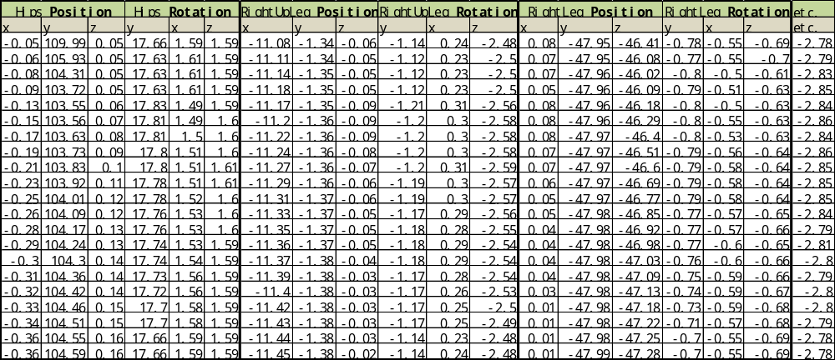

BVH data without displacement
不带位移的骨骼数据，除了根节点带有位移及姿态外，其他所有骨骼都只有姿态数据。
Sample data:
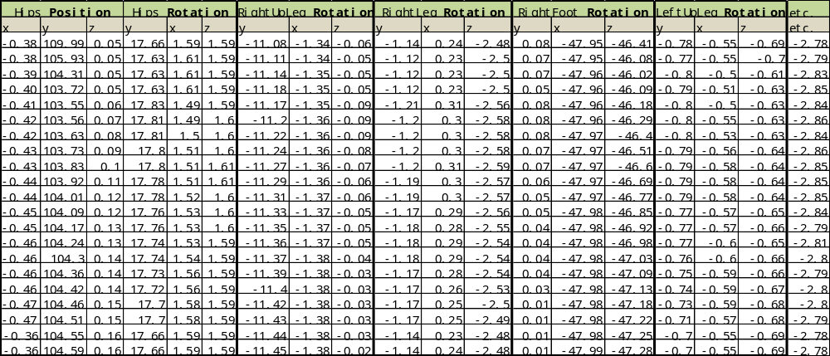

Coordinate of Displacement
The unit of displacement in BVH data is centimeter. Displacement is defined in local coordinate system of parent body segment, for hip (root): X axis points to the left of avatar, Y axis point to the up of avatar, Z axis point to the front of avatar.
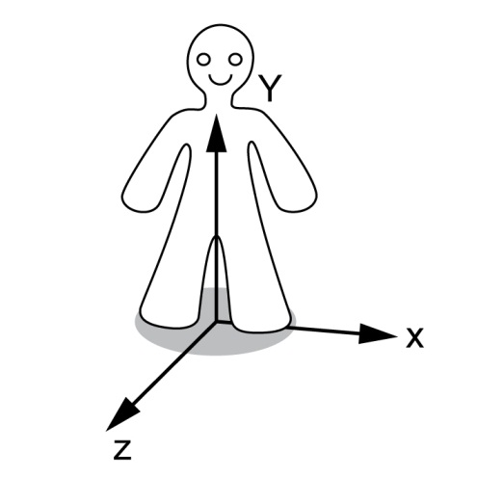
Left-Up-Front(xyz)

Order of Rotation
每根骨骼的姿态由三个旋转分量（Xrotation、Yrotation和Zrotation） 表示。旋转中心为骨骼的起始端点。
旋转分量是指伸出右手，大拇指指向坐标轴正方向，另外四指的弯曲方向即为正向旋转方向，旋转量即为旋转角度。
根据旋转的先后顺序的不同，姿态可分为六种表示方式： YXZ，XZY, XYZ, YZX, ZXY, ZYX。

Hierarchy of bone system
BVH骨骼继承关系体现在BVH头文件中，BVH格式是一个递归定义，层次结构中的每一segment包含仅仅关联该segment的部分数据，然后递归定义其子段。参见附录A、B。
1)“HIERARCHY”关键字：标识头文件开始，下一行起始于关键字“ROOT”。
2)“ROOT”关键字：标识根节点，紧接着“ROOT”关键字层次结构的root segment的名称被定义即Hips；“ROOT”关键字的下一行包含一个左大括号‘{’，该括号跟“ROOT”关键字并列；紧接着大括号的下一行是一个tab字符的缩进，这些缩进大多使得文件更可读；Segment的第一条信息就是对于其父segment的偏移，或者在root对象的情况下，偏移量为初始偏移量（Hip相对于地面的高度），偏移被关键字“OFFSET”指定，紧接着就是该segment对父segment的X，Y和Z的偏移量，偏移量信息也指示了用于绘制其父segment的长度和方向信息。在BVH格式中，没有任何关于如何绘制一个segment的明确信息，通常从父定义中的第一个子的偏移开始推断。
3)“CHANNELS”关键字：包含通道的头部信息，紧接着是一个数字指示数量，然后是一个标签列表指示每一个通道的类型。
4)“JOINT”关键字： Joint定义跟root定义相同，除了通道的数量，这就是发生递归的地方，其余的解析joint信息的处理就像root一样。
5)“End Site”关键字：End site信息终止递归并指示当前segment终止（无子节点），End site的定义提供了一些信息，它给出了前一segment的长度，就像子节点的偏移定义了它的父segment的长度和方向。
6)任意joint，end site或root定义的最后标记一个右大括号“}”，这个括号于其相对应的左括号并列。

Appendix

A. Header of BVH Data File with Displacement
HIERARCHY
ROOT Hips
{
OFFSET 0.000000 104.194260 0.000000
CHANNELS 6 Xposition Yposition Zposition Yrotation Xrotation Zrotation
JOINT RightUpLeg
{
OFFSET -11.500000 0.000000 0.000000
CHANNELS 6 Xposition Yposition Zposition Yrotation Xrotation Zrotation
JOINT RightLeg
{
OFFSET 0.000000 -48.000000 0.000000
CHANNELS 6 Xposition Yposition Zposition Yrotation Xrotation Zrotation
JOINT RightFoot
{
OFFSET 0.000000 -48.000000 0.000000
CHANNELS 6 Xposition Yposition Zposition Yrotation Xrotation Zrotation
End Site
{
OFFSET 0.000000 -1.806452 18.064516
}
}
}
}
JOINT LeftUpLeg
{
OFFSET 11.500000 0.000000 0.000000
CHANNELS 6 Xposition Yposition Zposition Yrotation Xrotation Zrotation
JOINT LeftLeg
{
OFFSET 0.000000 -48.000000 0.000000
CHANNELS 6 Xposition Yposition Zposition Yrotation Xrotation Zrotation
JOINT LeftFoot
{
OFFSET 0.000000 -48.000000 0.000000
CHANNELS 6 Xposition Yposition Zposition Yrotation Xrotation Zrotation
End Site
{
OFFSET 0.000000 -1.806452 18.064516
}
}
}
}
JOINT Spine
{
OFFSET 0.000000 13.878078 0.000000
CHANNELS 6 Xposition Yposition Zposition Yrotation Xrotation Zrotation
JOINT Spine1
{
OFFSET 0.000000 11.312473 0.000000
CHANNELS 6 Xposition Yposition Zposition Yrotation Xrotation Zrotation
JOINT Spine2
{
OFFSET 0.000000 11.779724 0.000000
CHANNELS 6 Xposition Yposition Zposition Yrotation Xrotation Zrotation
JOINT Spine3
{
OFFSET 0.000000 11.312473 0.000000
CHANNELS 6 Xposition Yposition Zposition Yrotation Xrotation Zrotation
JOINT Neck
{
OFFSET 0.000000 12.091224 0.000000
CHANNELS 6 Xposition Yposition Zposition Yrotation Xrotation Zrotation
JOINT Head
{
OFFSET 0.000000 9.000000 0.000000
CHANNELS 6 Xposition Yposition Zposition Yrotation Xrotation Zrotation
End Site
{
OFFSET 0.000000 18.000000 0.000000
}
}
}
JOINT RightShoulder
{
OFFSET -3.500000 8.060816 0.000000
CHANNELS 6 Xposition Yposition Zposition Yrotation Xrotation Zrotation
JOINT RightArm
{
OFFSET -17.500000 0.000000 0.000000
CHANNELS 6 Xposition Yposition Zposition Yrotation Xrotation Zrotation
JOINT RightForeArm
{
OFFSET -29.000000 0.000000 0.000000
CHANNELS 6 Xposition Yposition Zposition Yrotation Xrotation Zrotation
JOINT RightHand
{
OFFSET -28.000000 0.000000 0.000000
CHANNELS 6 Xposition Yposition Zposition Yrotation Xrotation Zrotation
JOINT RightHandThumb1
{
OFFSET -2.702960 0.206400 3.388480
CHANNELS 6 Xposition Yposition Zposition Yrotation Xrotation Zrotation
JOINT RightHandThumb2
{
OFFSET -2.746160 -0.644800 2.834744
CHANNELS 6 Xposition Yposition Zposition Yrotation Xrotation Zrotation
JOINT RightHandThumb3
{
OFFSET -2.126080 -0.808800 1.594552
CHANNELS 6 Xposition Yposition Zposition Yrotation Xrotation Zrotation
End Site
{
OFFSET -1.800000 -0.900000 1.800000
}
}
}
}
JOINT RightInHandIndex
{
OFFSET -3.500240 0.552000 2.148272
CHANNELS 6 Xposition Yposition Zposition Yrotation Xrotation Zrotation
JOINT RightHandIndex1
{
OFFSET -5.669520 -0.099200 1.085176
CHANNELS 6 Xposition Yposition Zposition Yrotation Xrotation Zrotation
JOINT RightHandIndex2
{
OFFSET -3.919920 -0.191200 0.199320
CHANNELS 6 Xposition Yposition Zposition Yrotation Xrotation Zrotation
JOINT RightHandIndex3
{
OFFSET -2.222000 -0.138400 -0.082208
CHANNELS 6 Xposition Yposition Zposition Yrotation Xrotation Zrotation
End Site
{
OFFSET -2.280000 0.000000 0.000000
}
}
}
}
}
JOINT RightInHandMiddle
{
OFFSET -3.673840 0.561600 0.822346
CHANNELS 6 Xposition Yposition Zposition Yrotation Xrotation Zrotation
JOINT RightHandMiddle1
{
OFFSET -5.618239 -0.091200 0.341108
CHANNELS 6 Xposition Yposition Zposition Yrotation Xrotation Zrotation
JOINT RightHandMiddle2
{
OFFSET -4.273920 -0.291200 -0.200651
CHANNELS 6 Xposition Yposition Zposition Yrotation Xrotation Zrotation
JOINT RightHandMiddle3
{
OFFSET -2.668640 -0.207200 -0.240782
CHANNELS 6 Xposition Yposition Zposition Yrotation Xrotation Zrotation
End Site
{
OFFSET -2.280000 0.000000 0.000000
}
}
}
}
}
JOINT RightInHandRing
{
OFFSET -3.653760 0.588000 -0.140000
CHANNELS 6 Xposition Yposition Zposition Yrotation Xrotation Zrotation
JOINT RightHandRing1
{
OFFSET -5.000000 -0.024000 -0.521600
CHANNELS 6 Xposition Yposition Zposition Yrotation Xrotation Zrotation
JOINT RightHandRing2
{
OFFSET -3.652000 -0.285600 -0.742400
CHANNELS 6 Xposition Yposition Zposition Yrotation Xrotation Zrotation
JOINT RightHandRing3
{
OFFSET -2.548000 -0.186400 -0.441600
CHANNELS 6 Xposition Yposition Zposition Yrotation Xrotation Zrotation
End Site
{
OFFSET -2.160000 0.000000 0.000000
}
}
}
}
}
JOINT RightInHandPinky
{
OFFSET -3.432800 0.509600 -1.304800
CHANNELS 6 Xposition Yposition Zposition Yrotation Xrotation Zrotation
JOINT RightHandPinky1
{
OFFSET -4.494400 -0.024000 -1.176000
CHANNELS 6 Xposition Yposition Zposition Yrotation Xrotation Zrotation
JOINT RightHandPinky2
{
OFFSET -2.848800 -0.164000 -0.904000
CHANNELS 6 Xposition Yposition Zposition Yrotation Xrotation Zrotation
JOINT RightHandPinky3
{
OFFSET -1.765600 -0.142400 -0.662400
CHANNELS 6 Xposition Yposition Zposition Yrotation Xrotation Zrotation
End Site
{
OFFSET -1.680000 0.000000 0.000000
}
}
}
}
}
}
}
}
}
JOINT LeftShoulder
{
OFFSET 3.500000 8.060816 0.000000
CHANNELS 6 Xposition Yposition Zposition Yrotation Xrotation Zrotation
JOINT LeftArm
{
OFFSET 17.500000 0.000000 0.000000
CHANNELS 6 Xposition Yposition Zposition Yrotation Xrotation Zrotation
JOINT LeftForeArm
{
OFFSET 29.000000 0.000000 0.000000
CHANNELS 6 Xposition Yposition Zposition Yrotation Xrotation Zrotation
JOINT LeftHand
{
OFFSET 28.000000 0.000000 0.000000
CHANNELS 6 Xposition Yposition Zposition Yrotation Xrotation Zrotation
JOINT LeftHandThumb1
{
OFFSET 2.702960 0.206400 3.388480
CHANNELS 6 Xposition Yposition Zposition Yrotation Xrotation Zrotation
JOINT LeftHandThumb2
{
OFFSET 2.746160 -0.644800 2.834744
CHANNELS 6 Xposition Yposition Zposition Yrotation Xrotation Zrotation
JOINT LeftHandThumb3
{
OFFSET 2.126080 -0.808800 1.594552
CHANNELS 6 Xposition Yposition Zposition Yrotation Xrotation Zrotation
End Site
{
OFFSET 1.800000 -0.900000 1.800000
}
}
}
}
JOINT LeftInHandIndex
{
OFFSET 3.500000 0.552000 2.148000
CHANNELS 6 Xposition Yposition Zposition Yrotation Xrotation Zrotation
JOINT LeftHandIndex1
{
OFFSET 5.668800 -0.099200 1.084800
CHANNELS 6 Xposition Yposition Zposition Yrotation Xrotation Zrotation
JOINT LeftHandIndex2
{
OFFSET 3.920000 -0.191200 0.199200
CHANNELS 6 Xposition Yposition Zposition Yrotation Xrotation Zrotation
JOINT LeftHandIndex3
{
OFFSET 2.221600 -0.138400 -0.082400
CHANNELS 6 Xposition Yposition Zposition Yrotation Xrotation Zrotation
End Site
{
OFFSET 2.280000 0.000000 0.000000
}
}
}
}
}
JOINT LeftInHandMiddle
{
OFFSET 3.673600 0.561600 0.822320
CHANNELS 6 Xposition Yposition Zposition Yrotation Xrotation Zrotation
JOINT LeftHandMiddle1
{
OFFSET 5.617840 -0.091200 0.340800
CHANNELS 6 Xposition Yposition Zposition Yrotation Xrotation Zrotation
JOINT LeftHandMiddle2
{
OFFSET 4.273600 -0.291200 -0.200800
CHANNELS 6 Xposition Yposition Zposition Yrotation Xrotation Zrotation
JOINT LeftHandMiddle3
{
OFFSET 2.668800 -0.207200 -0.240800
CHANNELS 6 Xposition Yposition Zposition Yrotation Xrotation Zrotation
End Site
{
OFFSET 2.280000 0.000000 0.000000
}
}
}
}
}
JOINT LeftInHandRing
{
OFFSET 3.653760 0.588000 -0.140000
CHANNELS 6 Xposition Yposition Zposition Yrotation Xrotation Zrotation
JOINT LeftHandRing1
{
OFFSET 5.000000 -0.024000 -0.521600
CHANNELS 6 Xposition Yposition Zposition Yrotation Xrotation Zrotation
JOINT LeftHandRing2
{
OFFSET 3.652000 -0.285600 -0.742400
CHANNELS 6 Xposition Yposition Zposition Yrotation Xrotation Zrotation
JOINT LeftHandRing3
{
OFFSET 2.548000 -0.186400 -0.441600
CHANNELS 6 Xposition Yposition Zposition Yrotation Xrotation Zrotation
End Site
{
OFFSET 2.160000 0.000000 0.000000
}
}
}
}
}
JOINT LeftInHandPinky
{
OFFSET 3.432800 0.509600 -1.304800
CHANNELS 6 Xposition Yposition Zposition Yrotation Xrotation Zrotation
JOINT LeftHandPinky1
{
OFFSET 4.494400 -0.024000 -1.176000
CHANNELS 6 Xposition Yposition Zposition Yrotation Xrotation Zrotation
JOINT LeftHandPinky2
{
OFFSET 2.848800 -0.164000 -0.904000
CHANNELS 6 Xposition Yposition Zposition Yrotation Xrotation Zrotation
JOINT LeftHandPinky3
{
OFFSET 1.765600 -0.142400 -0.662400
CHANNELS 6 Xposition Yposition Zposition Yrotation Xrotation Zrotation
End Site
{
OFFSET 1.680000 0.000000 0.000000
}
}
}
}
}
}
}
}
}
}
}
}
}
}

B. Header of BVH Data File without Displacement
HIERARCHY
ROOT Hips
{
OFFSET 0.00 102.39 0.00
CHANNELS 6 Xposition Yposition Zposition Yrotation Xrotation Zrotation
JOINT RightUpLeg
{
OFFSET -11.50 0.00 0.00
CHANNELS 3 Yrotation Xrotation Zrotation
JOINT RightLeg
{
OFFSET 0.00 -48.00 0.00
CHANNELS 3 Yrotation Xrotation Zrotation
JOINT RightFoot
{
OFFSET 0.00 -48.00 0.00
CHANNELS 3 Yrotation Xrotation Zrotation
End Site
{
OFFSET 0.00 -5.00 19.60
}
}
}
}
JOINT LeftUpLeg
{
OFFSET 11.50 0.00 0.00
CHANNELS 3 Yrotation Xrotation Zrotation
JOINT LeftLeg
{
OFFSET 0.00 -48.00 0.00
CHANNELS 3 Yrotation Xrotation Zrotation
JOINT LeftFoot
{
OFFSET 0.00 -48.00 0.00
CHANNELS 3 Yrotation Xrotation Zrotation
End Site
{
OFFSET 0.00 -5.00 19.60
}
}
}
}
JOINT Spine
{
OFFSET 0.00 13.88 0.00
CHANNELS 3 Yrotation Xrotation Zrotation
JOINT Spine1
{
OFFSET 0.00 11.31 0.00
CHANNELS 3 Yrotation Xrotation Zrotation
JOINT Spine2
{
OFFSET 0.00 11.78 0.00
CHANNELS 3 Yrotation Xrotation Zrotation
JOINT Spine3
{
OFFSET 0.00 11.31 0.00
CHANNELS 3 Yrotation Xrotation Zrotation
JOINT Neck
{
OFFSET 0.00 12.09 0.00
CHANNELS 3 Yrotation Xrotation Zrotation
JOINT Head
{
OFFSET 0.00 9.00 0.00
CHANNELS 3 Yrotation Xrotation Zrotation
End Site
{
OFFSET 0.00 18.00 0.00
}
}
}
JOINT RightShoulder
{
OFFSET -3.50 8.06 0.00
CHANNELS 3 Yrotation Xrotation Zrotation
JOINT RightArm
{
OFFSET -17.50 0.00 0.00
CHANNELS 3 Yrotation Xrotation Zrotation
JOINT RightForeArm
{
OFFSET -29.00 0.00 0.00
CHANNELS 3 Yrotation Xrotation Zrotation
JOINT RightHand
{
OFFSET -28.00 0.00 0.00
CHANNELS 3 Yrotation Xrotation Zrotation
JOINT RightHandThumb1
{
OFFSET -2.70 0.21 3.39
CHANNELS 3 Yrotation Xrotation Zrotation
JOINT RightHandThumb2
{
OFFSET -2.75 -0.64 2.83
CHANNELS 3 Yrotation Xrotation Zrotation
JOINT RightHandThumb3
{
OFFSET -2.13 -0.81 1.59
CHANNELS 3 Yrotation Xrotation Zrotation
End Site
{
OFFSET -1.44 -0.72 1.44
}
}
}
}
JOINT RightInHandIndex
{
OFFSET -3.50 0.55 2.15
CHANNELS 3 Yrotation Xrotation Zrotation
JOINT RightHandIndex1
{
OFFSET -5.67 -0.10 1.08
CHANNELS 3 Yrotation Xrotation Zrotation
JOINT RightHandIndex2
{
OFFSET -3.92 -0.19 0.20
CHANNELS 3 Yrotation Xrotation Zrotation
JOINT RightHandIndex3
{
OFFSET -2.22 -0.14 -0.08
CHANNELS 3 Yrotation Xrotation Zrotation
End Site
{
OFFSET -1.82 0.00 0.00
}
}
}
}
}
JOINT RightInHandMiddle
{
OFFSET -3.67 0.56 0.82
CHANNELS 3 Yrotation Xrotation Zrotation
JOINT RightHandMiddle1
{
OFFSET -5.62 -0.09 0.34
CHANNELS 3 Yrotation Xrotation Zrotation
JOINT RightHandMiddle2
{
OFFSET -4.27 -0.29 -0.20
CHANNELS 3 Yrotation Xrotation Zrotation
JOINT RightHandMiddle3
{
OFFSET -2.67 -0.21 -0.24
CHANNELS 3 Yrotation Xrotation Zrotation
End Site
{
OFFSET -1.82 0.00 0.00
}
}
}
}
}
JOINT RightInHandRing
{
OFFSET -3.65 0.59 -0.14
CHANNELS 3 Yrotation Xrotation Zrotation
JOINT RightHandRing1
{
OFFSET -5.00 -0.02 -0.52
CHANNELS 3 Yrotation Xrotation Zrotation
JOINT RightHandRing2
{
OFFSET -3.65 -0.29 -0.74
CHANNELS 3 Yrotation Xrotation Zrotation
JOINT RightHandRing3
{
OFFSET -2.55 -0.19 -0.44
CHANNELS 3 Yrotation Xrotation Zrotation
End Site
{
OFFSET -1.73 0.00 0.00
}
}
}
}
}
JOINT RightInHandPinky
{
OFFSET -3.43 0.51 -1.30
CHANNELS 3 Yrotation Xrotation Zrotation
JOINT RightHandPinky1
{
OFFSET -4.49 -0.02 -1.18
CHANNELS 3 Yrotation Xrotation Zrotation
JOINT RightHandPinky2
{
OFFSET -2.85 -0.16 -0.90
CHANNELS 3 Yrotation Xrotation Zrotation
JOINT RightHandPinky3
{
OFFSET -1.77 -0.14 -0.66
CHANNELS 3 Yrotation Xrotation Zrotation
End Site
{
OFFSET -1.34 0.00 0.00
}
}
}
}
}
}
}
}
}
JOINT LeftShoulder
{
OFFSET 3.50 8.06 0.00
CHANNELS 3 Yrotation Xrotation Zrotation
JOINT LeftArm
{
OFFSET 17.50 0.00 0.00
CHANNELS 3 Yrotation Xrotation Zrotation
JOINT LeftForeArm
{
OFFSET 29.00 0.00 0.00
CHANNELS 3 Yrotation Xrotation Zrotation
JOINT LeftHand
{
OFFSET 28.00 0.00 0.00
CHANNELS 3 Yrotation Xrotation Zrotation
JOINT LeftHandThumb1
{
OFFSET 2.70 0.21 3.39
CHANNELS 3 Yrotation Xrotation Zrotation
JOINT LeftHandThumb2
{
OFFSET 2.75 -0.64 2.83
CHANNELS 3 Yrotation Xrotation Zrotation
JOINT LeftHandThumb3
{
OFFSET 2.13 -0.81 1.59
CHANNELS 3 Yrotation Xrotation Zrotation
End Site
{
OFFSET 1.44 -0.72 1.44
}
}
}
}
JOINT LeftInHandIndex
{
OFFSET 3.50 0.55 2.15
CHANNELS 3 Yrotation Xrotation Zrotation
JOINT LeftHandIndex1
{
OFFSET 5.67 -0.10 1.08
CHANNELS 3 Yrotation Xrotation Zrotation
JOINT LeftHandIndex2
{
OFFSET 3.92 -0.19 0.20
CHANNELS 3 Yrotation Xrotation Zrotation
JOINT LeftHandIndex3
{
OFFSET 2.22 -0.14 -0.08
CHANNELS 3 Yrotation Xrotation Zrotation
End Site
{
OFFSET 1.82 0.00 0.00
}
}
}
}
}
JOINT LeftInHandMiddle
{
OFFSET 3.67 0.56 0.82
CHANNELS 3 Yrotation Xrotation Zrotation
JOINT LeftHandMiddle1
{
OFFSET 5.62 -0.09 0.34
CHANNELS 3 Yrotation Xrotation Zrotation
JOINT LeftHandMiddle2
{
OFFSET 4.27 -0.29 -0.20
CHANNELS 3 Yrotation Xrotation Zrotation
JOINT LeftHandMiddle3
{
OFFSET 2.67 -0.21 -0.24
CHANNELS 3 Yrotation Xrotation Zrotation
End Site
{
OFFSET 1.82 0.00 0.00
}
}
}
}
}
JOINT LeftInHandRing
{
OFFSET 3.65 0.59 -0.14
CHANNELS 3 Yrotation Xrotation Zrotation
JOINT LeftHandRing1
{
OFFSET 5.00 -0.02 -0.52
CHANNELS 3 Yrotation Xrotation Zrotation
JOINT LeftHandRing2
{
OFFSET 3.65 -0.29 -0.74
CHANNELS 3 Yrotation Xrotation Zrotation
JOINT LeftHandRing3
{
OFFSET 2.55 -0.19 -0.44
CHANNELS 3 Yrotation Xrotation Zrotation
End Site
{
OFFSET 1.73 0.00 0.00
}
}
}
}
}
JOINT LeftInHandPinky
{
OFFSET 3.43 0.51 -1.30
CHANNELS 3 Yrotation Xrotation Zrotation
JOINT LeftHandPinky1
{
OFFSET 4.49 -0.02 -1.18
CHANNELS 3 Yrotation Xrotation Zrotation
JOINT LeftHandPinky2
{
OFFSET 2.85 -0.16 -0.90
CHANNELS 3 Yrotation Xrotation Zrotation
JOINT LeftHandPinky3
{
OFFSET 1.77 -0.14 -0.66
CHANNELS 3 Yrotation Xrotation Zrotation
End Site
{
OFFSET 1.34 0.00 0.00
}
}
}
}
}
}
}
}
}
}
}
}
}
}

C. Bone System
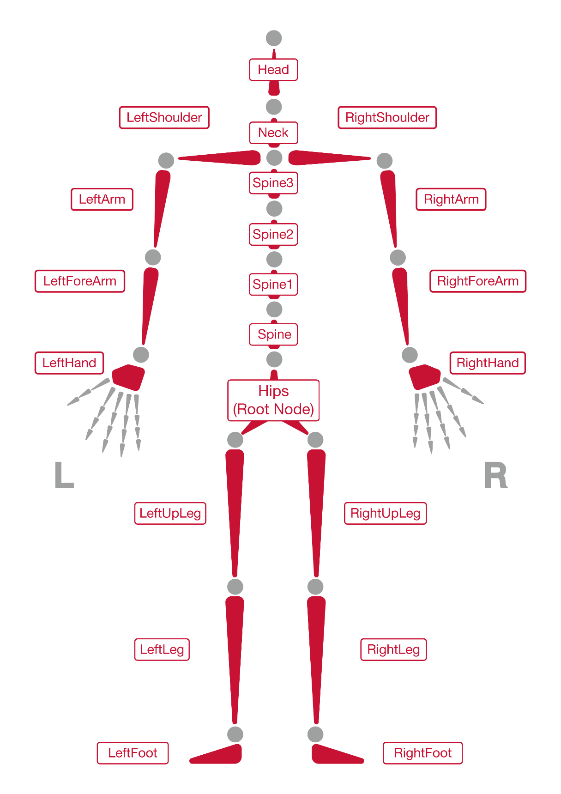
21根全身骨骼图

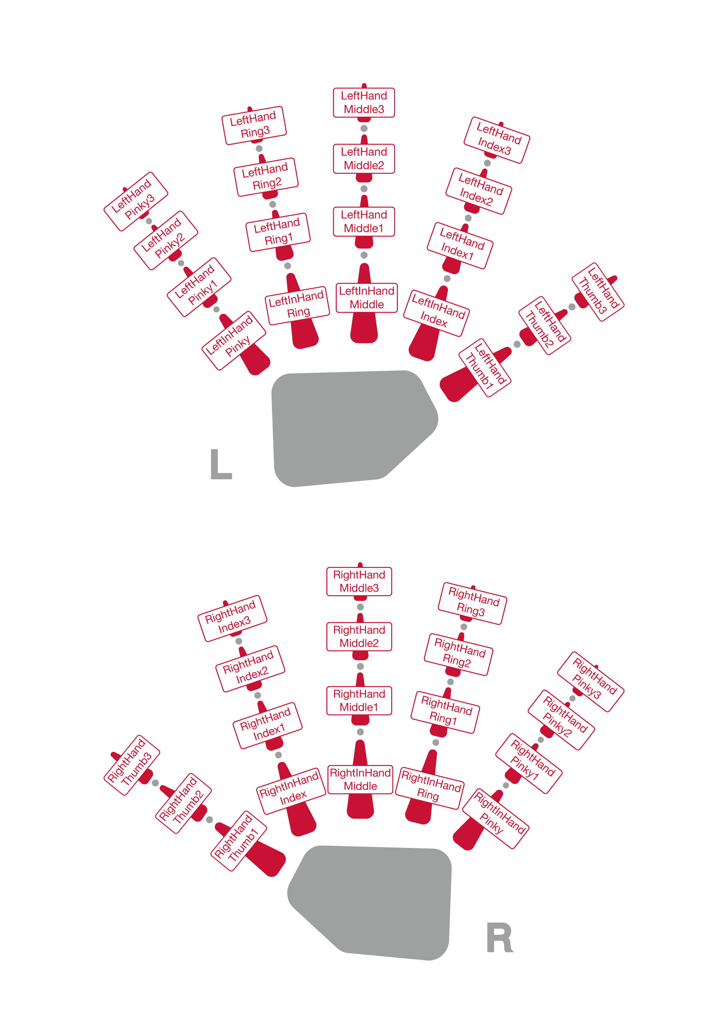
左右手分别19根手部骨骼图

Revision
Revision | Author |  | date | Description/changes
D1 | He Yuanhui |  | 7/1/2013 | Initial released
D2 | He Yuanhui |  | 1/6/2014 | Added:  Modified:  Data format desc.
D3 | He Yuanhui |  | 6/24/2014 | Added:  Modified:  Default service port.
D4 | He Yuanhui |  | 11/25/2014 | Added:  Add fingers data  Modified:
D5 | Chen Jinzhou |  | 12/25/2014 | Modified:
D6 | He Yuanhui |  | 1/21/2015 | Modified:  Data sample chart
D7 |  | Guo Haiwen | 5/14/2015 | Added:  Add Bone System Picture

